

**Smart Policies**Alanus von Radecki – 14/07/2016

Good regulations and incentives are a key prerequisite to creating a smart city. With regulations and incentives the decision making authorities are able to steer behaviour and investments and by this create a desired future for their cities.

**But what are Smart Policies and how can we best use them to make impact in our cities?**

This document provides guidance in terms of defining smart policies and highlighting some examples from cities around the world. It serves as aninitial document to SmartImpact member cities to start reflecting upon smart policies, collecting good examples from their own city and identifying the demand for better regulations and incentives.

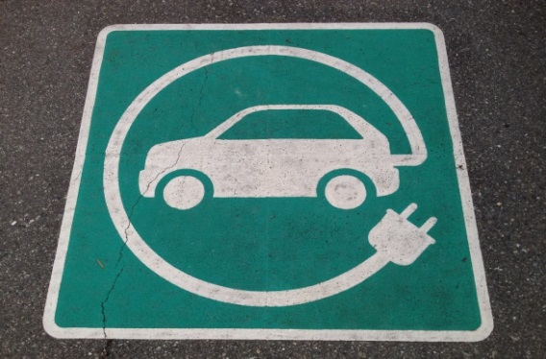

1. **What are smart policies?**

**Smart policies can be defined as** **locally adapted regulations and incentives** **that help to grow the economy in a sustainable way, support a reduction of the urban environmental footprint and increase the efficiency of public spending. Smart policies hit the leverage points in your city. They are able to provoke a large impact through a relatively small amount of change.**

* Smart policies do not have to be based on data, but using data usually provides the basis for successful smart policies and allows monitoring of their impact.
* Smart policies do not have to be embedded in large strategies or masterplans; they can be pretty specific and address single issues in a city - like parking, green areas or waste management.
* Smart policies are usually connected to our behaviour or to the behaviour of the market and manage to turn this into a positive contribution to a sustainable city.

**Examples of smart policies:**

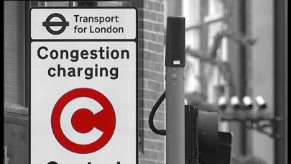

**Congestion charge zone London**

Congestion charging continues to make a valuable contribution to London’s transport network. It has reduced congestion and provided better transport services, cleaner air and safer roads. The primary aim of the Congestion Charge was to cut traffic levels and congestion in London. Traffic entering the original charging zone has remained stable at 27 per cent lower than pre-charging conditions in 2002. This means that nearly 80,000 fewer cars enter the original charging zone each day. Cycling levels in the Congestion Charging zone are also up by 66 per cent since the introduction of the scheme.

The Congestion Charge is an £11.50 daily tariff and payment enables motorists to drive around, leave and re-enter the charging zone as many times as required in one day. It was introduced by Transport for London (TfL) in February 2003, following extensive public and stakeholder consultation.

**Badenova Innovation Fund**



The badenova Innovation Fund for Climate and Water Protection is an innovative instrument for increasing local sustainability in and around the City of Freiburg and for generating regional investments in climate and water protection projects.

The innovation fund is ideally suited for helping to realize technologies, processes and projects with high risks due to a lack of experience or high start-up costs. In total, the Innovation Fund has funded 237 innovative projects with a total volume of over 25 million EUR, generating additional investments of > 100 million EUR into the city and the region.

**The policy behind the fund**: the City of Freiburg holds 33% of the shares of the regional energy provider Badenova. Because of this the city is able to strategically influence the decision making of the company. Freiburg added a regulation into the constitution of the company which ensures that each year the company sets aside 3% of its profits (an average of about 1.5 million €) for investing in exemplary regional projects addressing climate and water protection issues. This policy has not only triggered innovation and growth in the region but has also resulted in new solutions for Badenova, which ultimately have generated a higher return on investment.

**Low Emission Vehicles in Stockholm**

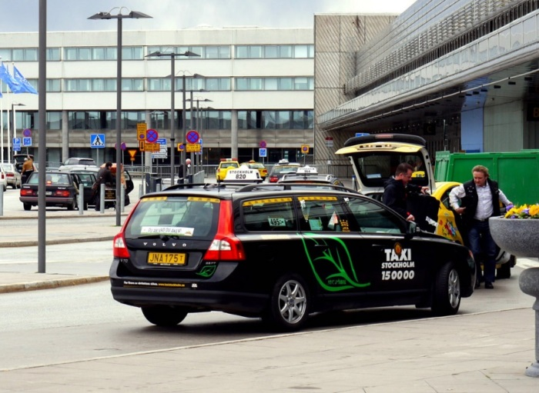The city of Stockholm started its programme to introduce “clean vehicles” in 1994 with the long term goal of replacing the fleet of conventional vehicles to reduce the negative impact of road traffic in the city.

To achieve this goal the city implemented several different measures and two of these stand out as incentives for population to advance towards their long term goal:

1. Free parking for electric vehicles was introduced in Stockholm in May 2005 and applied until the end of 2008. This saved electric car owner’s around 70 USD per month but to enjoy this benefit vehicles needed to meet the Traffic Administration’s requirements.
2. At the Stockholm-Arlanda airport a separate queue which positioned environmentally friendly taxis before conventional taxis was implemented. The adoption of clean vehicles was very successful and by 2011 it was decided that only “Eco taxis” would be accepted in the airport.

**Sustainable Building principles**

In 2009 Freiburg’s City Council passed the “building prin­ciples”, a living document for anchoring social, environmental and financial sus­tainability objectives within city development. Through use of the Building Principles, the city both ensures that all urban development planning procedures, which create additional building permits, as well as all purchase agreements for urban building plots, follow the same prin­ciples in regard to financing and social and ecological stan­dards.

Effect: All new buildings have to fulfil social, econo­mic and ecological standards. By way of the building principles the city ensures that wise decisions from the past get institutionalized within the processes of city planning. If better solutions come up, the principles are revised and updated. Since then, it has been the central instrument for sustainable city development. Aspects of the principles focus on:

* **Refinancing:** All city services for the creation of building permits must be refinanced by the plan­ning beneficiaries. This applies to planning servi­ces, appraisals, and infrastructure facilities as well as for the provision or financing of the care service fields for over 30 years.
* **Kindergarden:** The costs for required kindergar­ten places for the planned area must be incurred by the investor – must thus also be funded by the construction project.
* **Subsidized Housing:** The investor commits to im­plement subsidized rental and ownership housing in 30% of newly created living space. If this is not feasible, the city receives 10% of the area for mea­sures in subsidized housing.
* **Energy requirements:** Building projects must meet the energy standards of the city, which are higher than national legislation (currently the Freiburg Efficiency House 55+ for residential buildings and the Freiburg Efficiency House 70+ for office and service buildings).
* **Realization of urban functions:** “building areas with particular urban importance are reserved for certain functions required in the district, e.g. local amenities, services, or social infrastructure”).
* **Set minimum proportion of housing and a mix of different living space sizes.**

For private areas, the content of the Building Land Princip­les is transferred into the land use plan via the **urban de­velopment contracts** instrument and then agreed upon in a legally binding manner between the city and the investor. For areas owned by the city, these principles are included in the purchase contract.

1. **Background information on Smart Policies**

As we have identified smart policies as mix of regulations and incentives, we can distinguish four main dimensions of smart policies[1] in our cities:

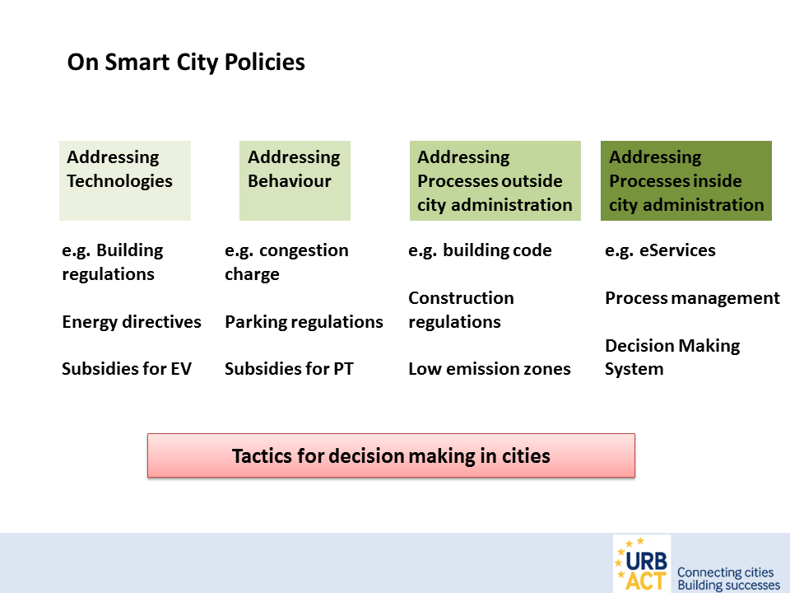

1. **Addressing technologies**

Clean technologies – and more and more connected technologies – offer cities a range of options to improve services and quality of life, reduce their footprint and grow their local economy. *Intelligent lighting* for example can serve to improve parking, enhance security, collect sensor-based city data and save energy at the same time. However we have to generate hundreds of policies around technologies in order to make sure that the right technologies get implemented.

In general we can distinguish between three different types of policies that address smart technologies:

1. **Policies targeting the distribution of efficient technologies.**

This policy modelis largely distributed and applied with clean technologies like efficient motors, CHP power stations, LED lights, AAA+ electronic devices, water-saving shower heads, isolated houses or the use of heat pumps etc. The main innovation of the efficiency model lies within one single piece of technology or one clearly defined product, which generates return on investment through, for example, energy savings over a certain amount of time. This makes market uptake rather easy (Weizsäcker 2009). **Policies on efficient technologies** usually target transparency for customers (certification, labelling, and benchmarks) or give purchase support by introducing or facilitating models like contracting, loans etc.

1. **Policies targeting the competitiveness of smart / clean technologies**

This model is strongly used in creating renewable energies and energy markets, or for overcoming lock-in structures of established socio-technical systems. We encounter it wherever governments seek to support politically desired technologies and there is a financial gap between the efficiency model and a profitable business model (e.g. see Nijkamp und Perrels 1994; Evans 2005; Cumo et al. 2012). The investor then invests into the clean technology and receives an additional bonus (in terms of granted return on investment or investment support) that allows for a profitable return on invest. Examples for this are feed in tariffs for solar and wind energy, subsidies for electric vehicles or market regulations like **taxes**, **fees** (e.g. for polluting cars) **caps** (e.g. emissions trading schemes) or **bans** (e.g. for FCKW).

1. **Policies targeting distributed benefits of smart technologies**

With digitalization and the Internet of Things (IoT) a new organizational and economic model for connected clean and efficient technologies is starting to develop and it promises to be substantially different from the two incumbent approaches towards financing clean technologies – the efficiency and the policy model.

Intelligent solutions that connect a range of technologies for a larger benefit not only have the potential to drastically increase efficiency, they also produce a range of **additional benefits** for many different actors. The sustainability potential of these solutions cannot be harnessed through conventional business models and regulations or subsidies. New approaches are needed today to prove the potential of smart and connected solutions and to develop collective investment schemes that relate individual benefits with joint investments. Very little policies are available that make effective use of distributed benefits. They are directed at **systems integration, data management and crowd-investment**, or they require a **combination of several policies** (*e.g. zoning + free parking + free energy provision + use of bus-lanes to create an electric car-sharing system*) to make distributed solutions successful.

1. **Addressing behaviour**

By integrating citizens into a continuous process of engagement and communication, urban services can become much more adapted to the needs of service users (citizens) and service deliverers (the municipality). Behavioural change is probably the single most important lever that we have to make our cities smarter and more liveable. It can be induced on various levels and there are also 3 different types of policies that address people’s behavior:

1. **Regulations, fines, restrictions**

Unwanted behaviour is made expensive and uncomfortable. High parking fees, fines for public nuisance or for driving too fast etc. are good examples for these policies. Most of these policies are necessary, but they come with rather high costs for municipalities (surveillance, law-enforcement) and they are often unpopular. Wherever regulations and rules need to be enacted to change the behaviour of a social group in your city, make sure that social control replaces public control wherever possible.

1. **Policies rewarding positive behaviour**

Rewards for a positive behaviour (e.g. Job-Tickets, lower charges, pay-back incentives etc.) do make people change the way they behave. Rewards, however, tend to have short-term effects only, for as long as the reward is in place. Moreover, rewards will be effective only if they are successful in making a specific desired behaviour more attractive than other options, in activating goals to change behaviour, and in facilitating the implementation of such goals. Rewards in themselves may not be successful in doing so ({Steg 2009 #26}).

1. **Nudges and Gamification**

Nudges is a concept in behavioural science, political theory and economics which argues that positive reinforcement and indirect suggestions to try to achieve non-forced compliance can influence the motives, incentives and decision making of groups and individuals, at least as effectively – if not more effectively – than direct instruction, legislation, or enforcement. Nudge is any aspect of the choice architecture that alters people’s behaviour in a predictable way without forbidding any options or significantly changing their economic incentives. To count as a mere nudge, the intervention must be easy and cheap to avoid. Nudges are not mandates. Putting fruit at eye level counts as a nudge. Banning junk food does not.

Here are some good videos on nudges.

<https://www.youtube.com/watch?v=jsy1E3ckxlM>

<https://www.youtube.com/watch?v=SByymar3bds>

1. **Addressing processes outside the city administration**

Many activities and processes that happen in our cities are not subject to an actual involvement of the city administration. Nonetheless they may have a large impact on life quality, the environmental footprint of the economy of the city.

Be it urban logistics and freight traffic, building processes, a specific production process or even just leisure on a golf course. All those processes usually need a regulation in order to function in a way that allows the city metabolism to function properly and to maximize the parallel existence of different activities by at the same time minimizing negative impacts on citizens, the environment of the economy.

* Policies directed at processes outside the city administration tend to focus on spatial compatible multi-functionality, with particular co-existence of different activities (like housing and business). You might want to think of building regulations, noise control, speed-limits, centre concepts or low emission zones as policies in this category.
* Other policies in this category also promote efficient urban services. This could for example refer to regulations for municipal subcontractors to provide their data in the same database with a specific standard, or, to local companies to disclose their environmental data in a standard database provided by the city administration.

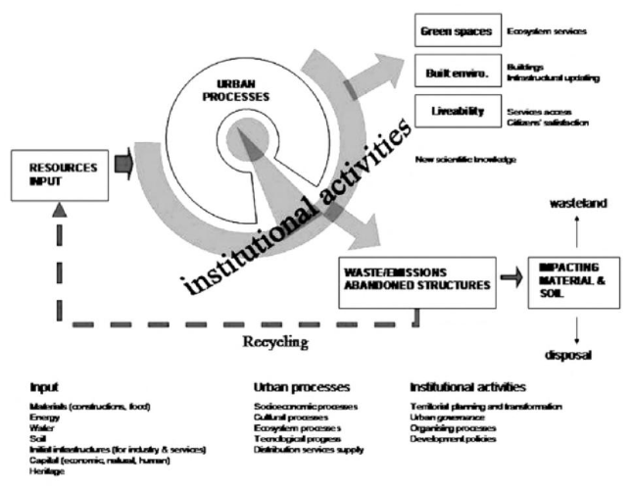

{Costa 2008 #28}

1. **Addressing processes inside city administration.**

*The smartest policies are sometimes those that address the origin of urban management and administration.* In city administrations several processes are running in parallel – and often not in a very co-ordinated way. Underground works of telecommunications providers, water companies, electricity companies or road refurbishment often happen uncoordinated and autonomous of each other. Yet, if coordinated, they could drastically increase efficiency of spendings and reduce emissions and waste. Coordinating these activities through smart policies (e.g. by defining who needs to be involved in which process) can have a large lever on the city.

The same applies to procurement processes, traffic management, civil security etc.

*Urban data platforms* have the potential to integrate several kinds of urban data-sets for enhancing the delivery of urban services and improve the efficiency of the city administration. Information about waste processes, street lighting, parking spaces, urban delivery services, available renewable energies and much more can be provided in real-time and within a single data platform. Policies targeting the development and co-ordinated use of urban data platforms (or data-based management systems in the city administration) are likely to develop a large effect on many other processes in the city.

1. **Background information on Regulations and Incentives**

Apart from the four types of policies described above, we can assess and analyse policies by looking at the sector at which regulations and incentives are directed.

With regards to smart cities there are four main areas of regulation:

* Urban mobility systems
* Urban energy systems
* Urban buildings
* Urban ICT systems

The following section gives an overview of the regulations and incentives that you might find in these areas in your city or in other cities across Europe:

**Regulations and incentives in the transport sector**

* Congestion charges for inner city districts.
* Special emission limits to preserve air quality.
* Regulatory low emission zones in the city.
* Regulations concerning noise control (e.g. speed limits, ban on night journeys)?
* Incentives for the use of e-mobility, bikes or public transport
* Free parking slots for e-vehicles
* Electrical vehicles are allowed to use special lanes (e.g. bus lanes).
* Incentives for buying e-vehicles (e.g. reduction in carbon tax or purchase incentives).

**Regulations and incentives in the building sector**

* The city is offering (financial) incentives for private households and companies to refurbish their buildings.
* Specific loans with favourable conditions are available (local or national level) for refurbishment.
* Specific energy requirements for new buildings in the city.
* National or local incentives for energy efficient buildings.
* Investors are obligated to finance needed (social) infrastructures.
* Regulations are in place to minimize pollution, noise and traffic in construction.
* Mandatory life cycle analysis for new construction projects
* Control mechanism to ensure the standards are met

**Regulations and incentives in the energy sector**

* The energy and resource flows in the city have been investigated.
* The city has set goals for increased energy efficiency.
* The city runs programs to educate citizens about energy efficient behaviour?
* There is a CO2 tax – or emission trading schemes.
* The city provides incentives in the industrial sector to reduce energy consumption.
* Are there feed-in tariffs for RE available in your country / city?
* Financial Support programs for the installation of solar panels, wind-energy or biomass plants with subsidies or other incentives.
* The potential for RE generation in the city and the surroundings has been assessed and identified.
* There is an existing regulation for the local energy provider (e.g. on CO2 emissions reduction)
* The city obliges investors to install or use renewable energies.

**Regulations and incentives in the ICT sector**

* The city is running a combined and centralized data management system (e.g. single data analytics centre).
* The city has enacted a public sector information regulation (disclosure of public data).
* The city has or plans an open data portal / strategy.
* The city has a smart city agenda.
* Energy efficiency goals and building automatization are linked to a data-based approach.
* The mobility management (especially EV) is linked to a data-based approach?

1. As part of the official trias (policy, politics and policy) it is a set of [ideas](http://dictionary.cambridge.org/dictionary/english/idea) or a [plan](http://dictionary.cambridge.org/dictionary/english/plan) of what to do in [particular](http://dictionary.cambridge.org/dictionary/english/particular) [situations](http://dictionary.cambridge.org/dictionary/english/situation) that has been [agreed](http://dictionary.cambridge.org/dictionary/english/agreed) to [officially](http://dictionary.cambridge.org/dictionary/english/officially) by a [group](http://dictionary.cambridge.org/dictionary/english/group) of [people](http://dictionary.cambridge.org/dictionary/english/people), here the city council and city administration.